EIE3112 SQL Quiz (2021/22 sem 2)

The questions are based on this ERD.

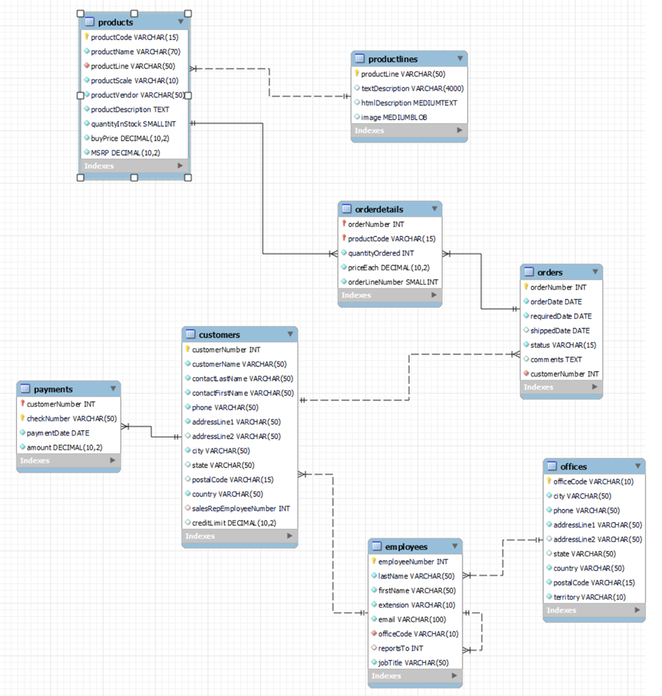

1. Please login to <https://codatus.app>
2. Go to EIE3112 > SQL Quiz
3. Follow the instructions from Part 1 to Part 11 to build the database. You may execute the CREATE TABLE statements and INSERT statements in the editor of question 1.
4. If you do not want to submit on Codatus or encounter any connection/submission problem on Codatus, you may type/write your answers below and send to me at pauli.lai@polyu.edu.hk for manual grading before 13:35. No late submission will be accepted.
5. Note that there is no partial mark awarded. Each question will score 0 mark or full mark based on the correctness of the output result.

|  |  |  |  |
| --- | --- | --- | --- |
| Question | Answer | Sample outputs | Marks |
| Q1. List the last name, first name and office code of all employees whose office code is greater than 5. | SELECT lastName, firstName, officeCode  FROM employees  WHERE SUBSTRING(officeCode) > 5 |  | 1 |
| Q2. Display all the different order statuses. Remove duplicates. | SELECT DISTINCT status  FROM orders |  | 1 |
| Q3. Display the office code, city and phone number of offices in the USA and France. (Hint: USA and France are countries.) | SELECT officeCode, city, phone  FROM offices  WHERE country = ‘USA’ OR country = ‘France’ |  | 2 |
| Q4. Display the product code, product name and buy price of all products where buy price is below 20 or above 100. | SELECT productCode, productName, buyPrice  FROM products  WHERE buyPrice < 20 OR buyPrice > 100 |  | 2 |
| Q5. Display the order number and the number of different products per order. Sort by order number in ascending order. | SELECT orderNumber, SUM(quantityOrdered) AS ‘no of products’  FROM orderdetails  GROUP BY orderNumber  ORDER BY orderNumber |  | 3 |
| Q6. Display the order number and the ordered quantity for those orders with ordered quantity between 5 and 10. Also, the order number should be between 10400 and 10420. Sort the list by quantity in descending order, and then by order number in ascending order. | SELECT orderNumber, SUM(quantityOrdered) AS ‘quantityOrdered’  FROM orderdetails  WHERE (orderNumber BETWEEN 10400 AND 10420) AND (`quantityOrdered` BETWEEN 5 AND 10)  GROUP BY orderNumber  ORDER BY `quantityOrdered` DESC, orderNumber |  | 3 |
| Q7. Display the customer number and customer name of the customers who have not placed any order. Sort the list by customer number. (Hint: use LEFT join or RIGHT join) | SELECT customerNumber, customerName  FROM customers LEFT JOIN(`orders`) ON customers.customerNumber = `orders`.customerNumber  WHERE orders.customerNumber IS NULL  ORDER BY customerNumber |  | 4 |
| Q8. Display the customer name and the number of payments for the customer. Sort by customer name. | SELECT customers.customerName, COUNT(payments.checkNumber) AS ‘no of payments’  FROM customers INNER JOIN(payments) ON customers.customerNumber = payments.customerNumber  GROUP BY customers.customerName, payments.customerNumber  ORDER BY customers.customerName |  | 4 |
| Q9. Display the order number, customer number, status and shipped date of all orders where total price is higher than 60000. Sort by order number. (Hint: Total price is the sum of (quantity * price for each product)) | SELECT `orders`.orderNumber, `orders`.customerNumber, `orders`.status, `orders`.shippedDate  FROM `orders` INNER JOIN(orderdetails) ON `orders`.orderNumber = orderdetails.orderNumber  WHERE status = ‘shipped’  GROUP BY orderdetails.orderNumber  HAVING SUM(orderdetails.quantity* orderdetails.priceEach) > 60000  ORDER BY `orders`.orderNumber |  | 5 |
| Q10. Display the year and the *total turnover for 'shipped' orders per year, starting from year 2004. Sort the list by year in ascending order. (Hint: use YEAR() function)  *total turnover for 'shipped' orders = total order price for all the orders with status of 'Shipped' | SELECT YEAR(`orders`.shippedDate) AS ‘year’, SUM(orderdetails.quantity* orderdetails.priceEach) AS ‘total turnover’  FROM `orders` INNER JOIN(orderdetails) ON `orders`.orderNumber = orderdetails.orderNumber  WHERE `orders`.status = ‘shipped’  GROUP BY `year`  ORDER BY `year` |  | 5 |